**EXP NO 3**Create a simple cloud software application for Car Booking Reservation System using any Cloud Service Provider to demonstrate SaaS include the necessary fields such as search for cabs, from, to, rental, out station, Package type, hours/Days etc.

**PROCEDURE**

**STEP 1** GO TO ZOHO.COM

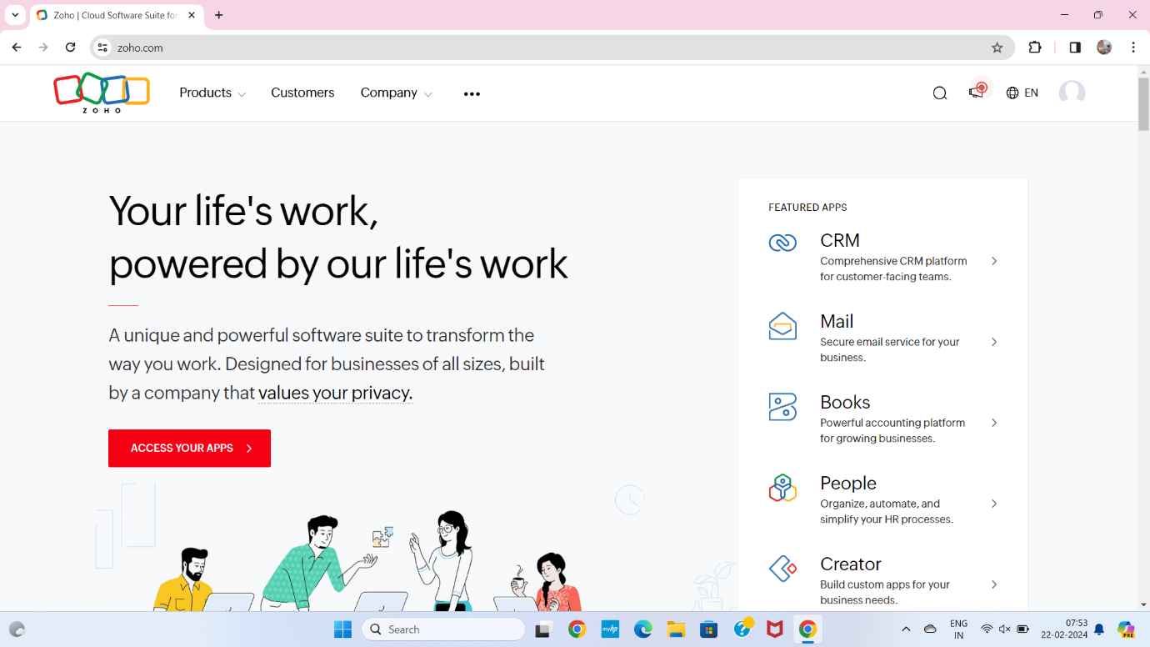

**STEP2** LOGIN TO THE ZOHO.COM

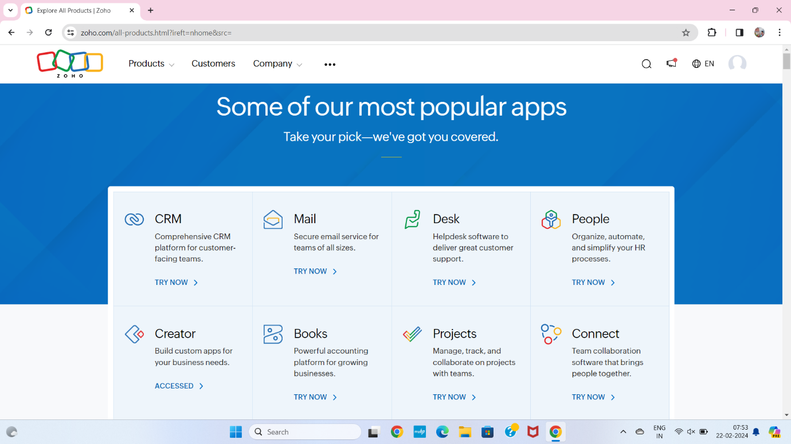

**STEP3**SELECT A CREATE FROM SCRATCH

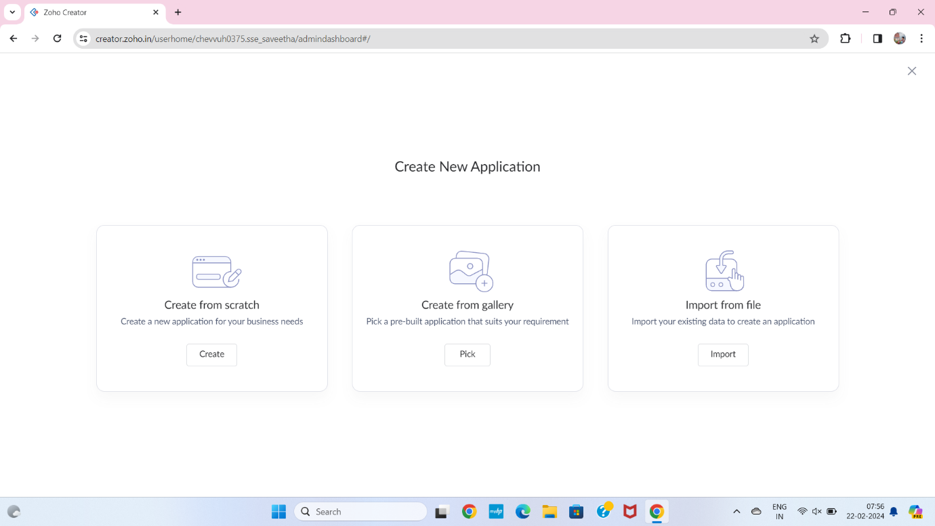

**STEP 4**SELECT APPLICATION NAME AS CAB BOOKING RESERVATION SYSTEM

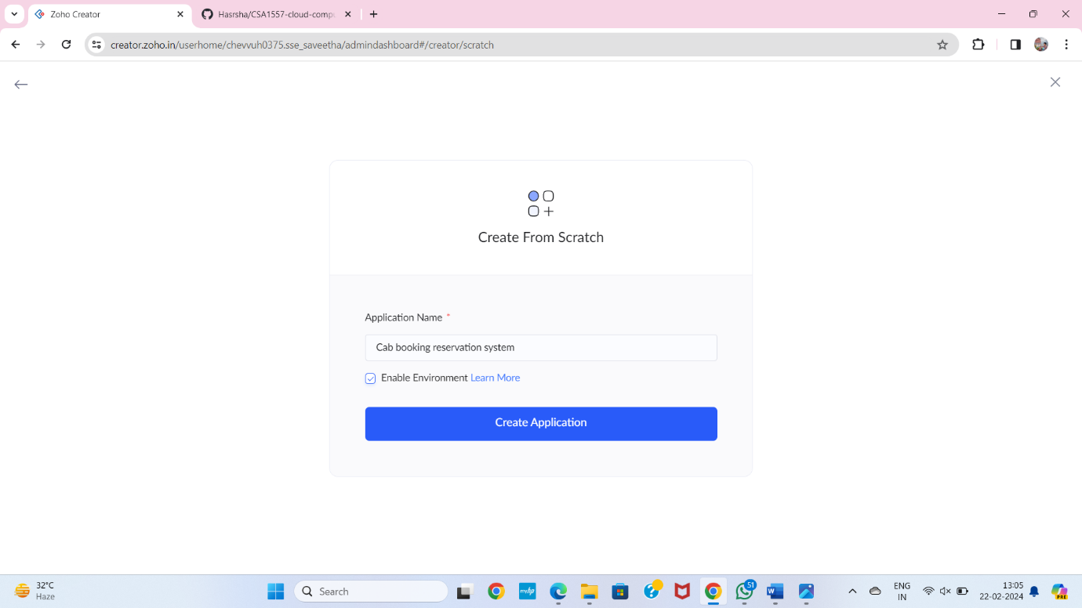

**STEP 5** CREATE A NEW FORM

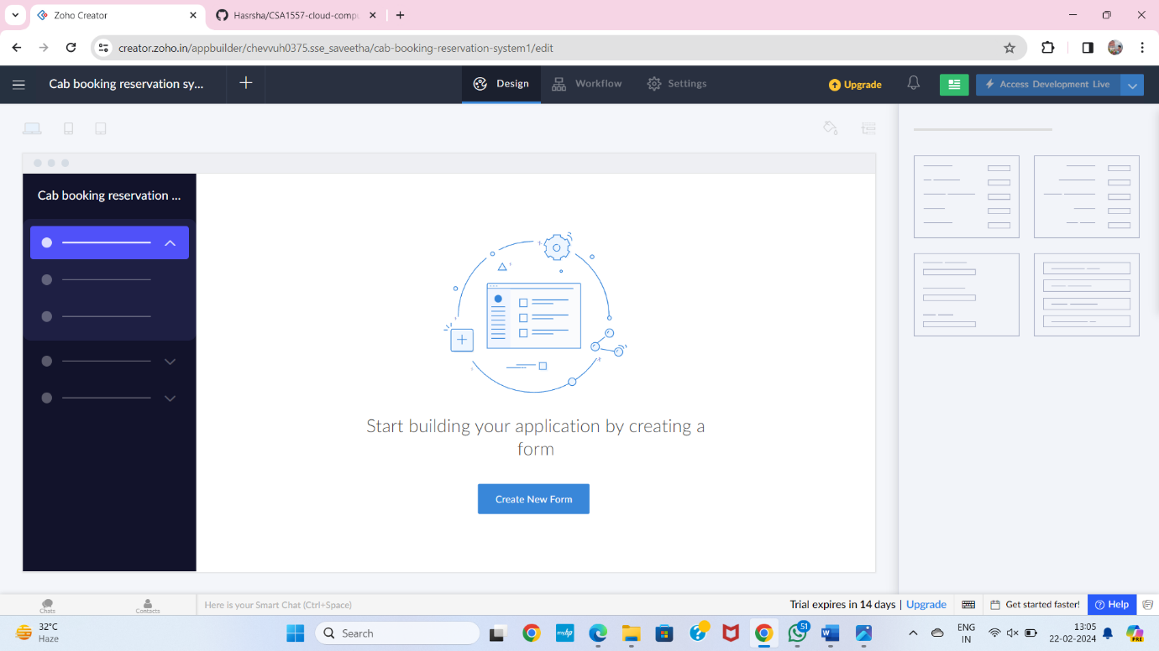

**STEP 6** SELECT BASIC FIELD FROM GIVEN BELOW AND DEVELOP APPLICATION

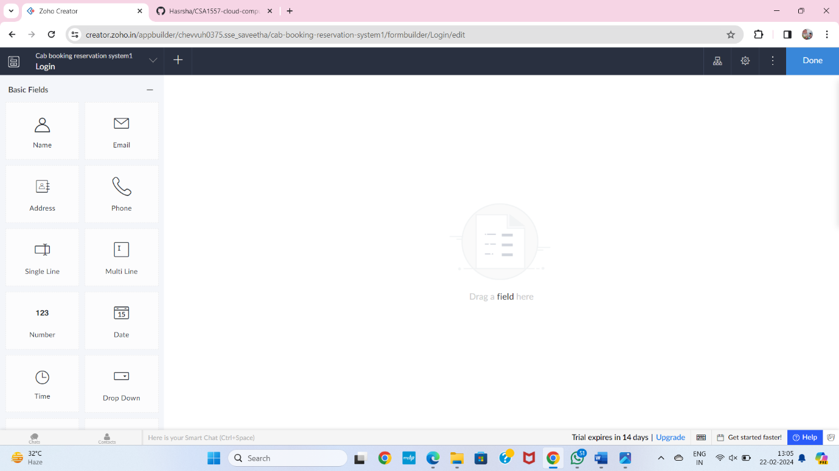

**STEP 7**THE SOFTWARE HASE BEEN CREATED LOGIN PAGE

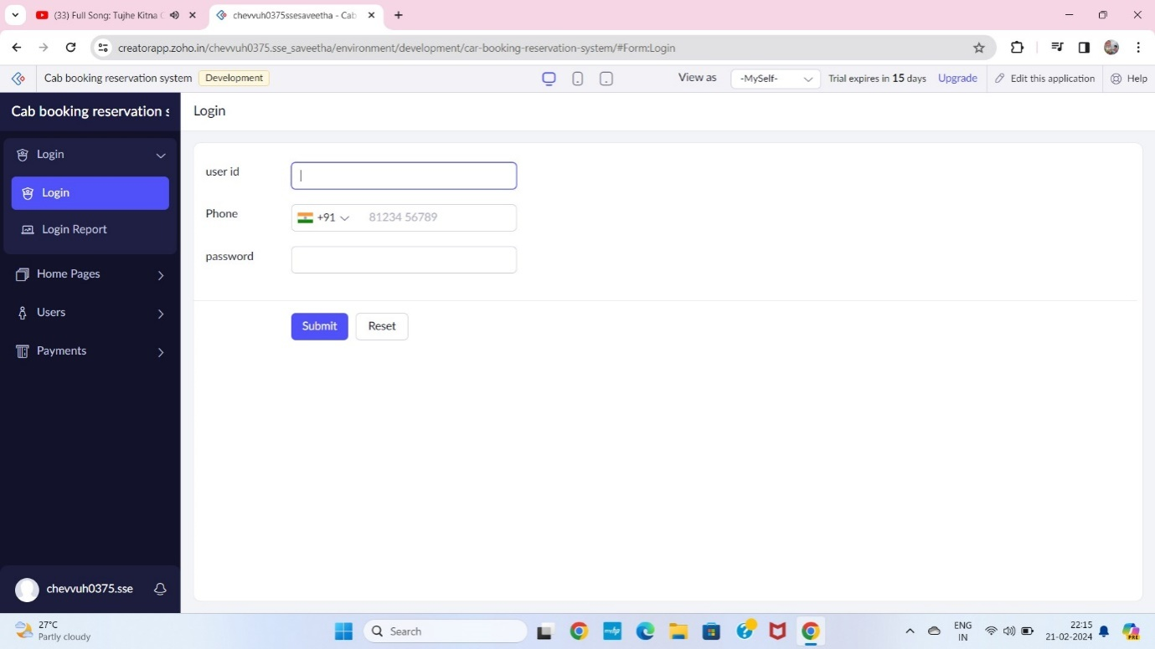

**STEP 8**THE SOFTWARE HASE BEEN CREATED HOME PAGE

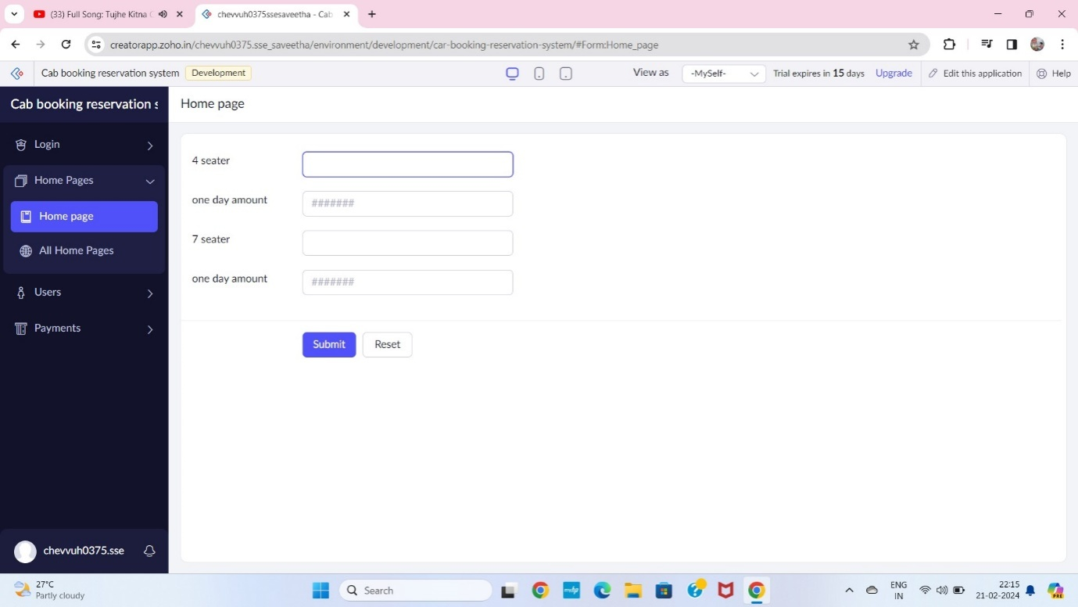

**STEP 9** THE SOFTWARE HASE BEEN CREATEDUSER

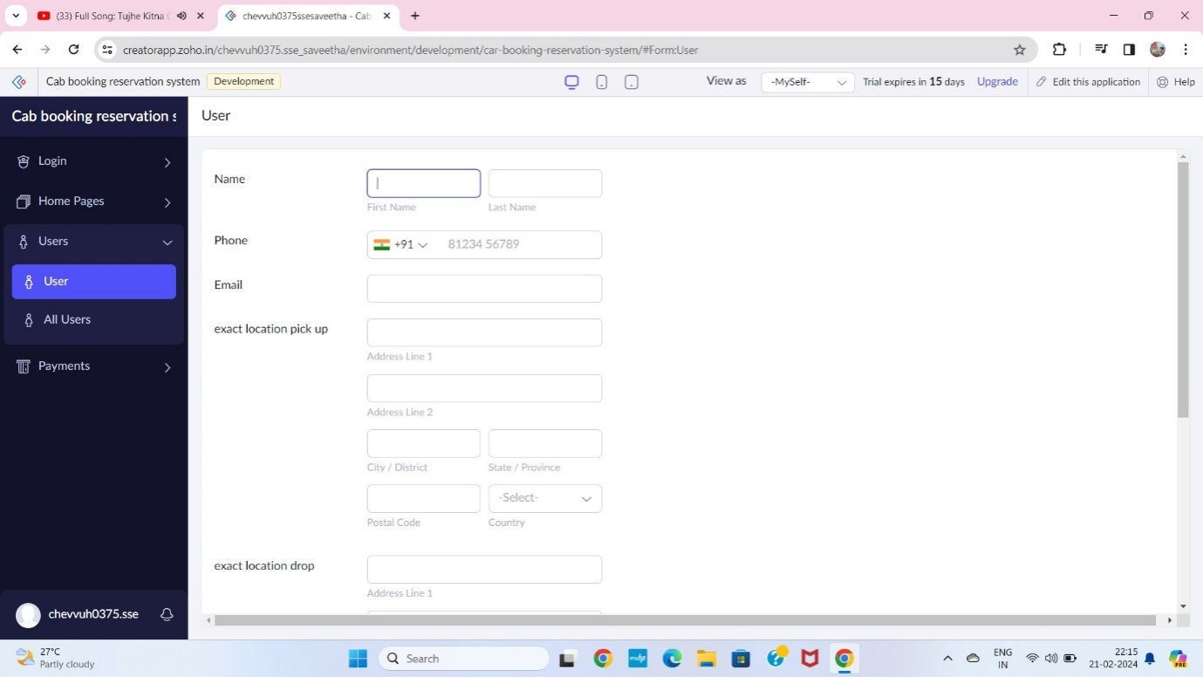

**STEP 10** THE SOFTWARE HASE BEEN CREATEDPAYMENT

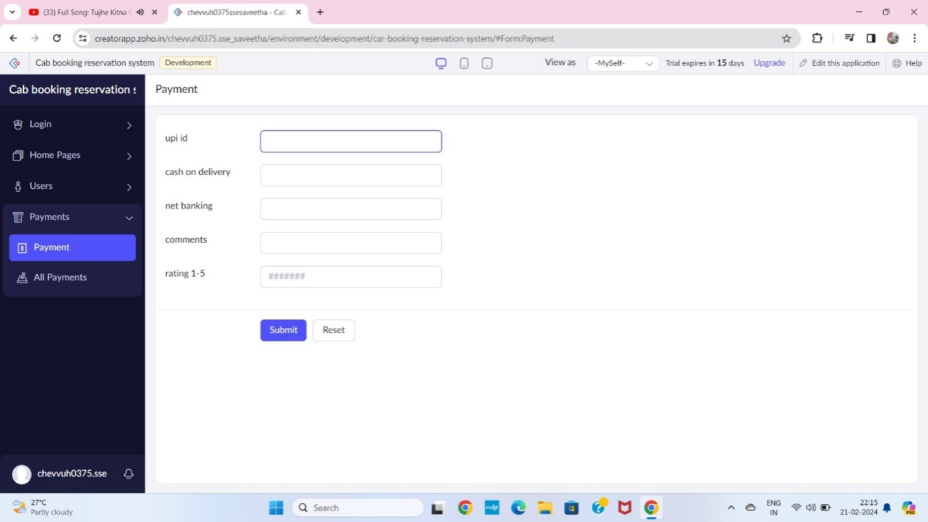

**STEP 12** THE SOFTWARE HASE BEEN CREATED

